Note: Include this page only when adding / amending / deleting a document. If using this document as a record, this Revision History page can be omitted.

REVISION HISTORY

Revision no | Date | Description of Changes | Reason for Revision | Revised by | Approved by
1 | 20 Jun 12 | Add revision history page | Recommendation from Stage 2 audit | CMRojas
2 | 8 Apr 16 | Added disclaimer when printing the document | For document control | RCGanal | MVBergantin
TM-BR-MG- 11 Rev02, 10302015

I. Objective
To efficiently transport items from CPI employees to CPI customers or vice versa on the agreed timeline.

II. Scope
This procedure defines the action and responsibilities of the Communications Delivery Staff and the Administrative Assistant in communications delivery service. This covers activities from the receipt of the request to the validation of the report.

III. Definition of Terms
Messenger Logbook | Shows the list of the received requests: action to be made, items , receiving party and destination.
Messenger Delivery Report | Reflects the itinerary of the messenger and the status of the requests.
Transportation Expense Summary | Shows the amount incurred by the Communications Delivery Staff in delivering the service.

IV. Procedure Details
RESPONSIBLE | ACTIVITY | INTERFACE
Administrative Assistant  Communications Delivery Staff | 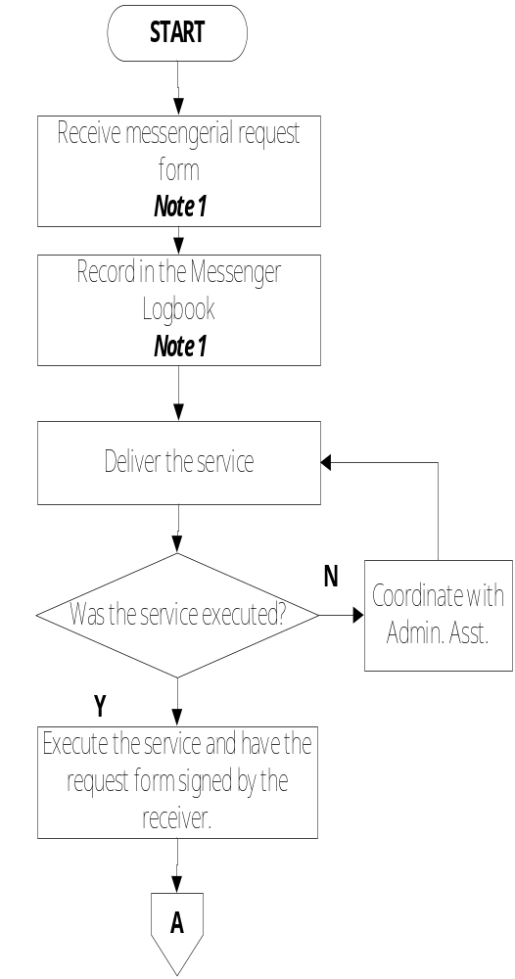 | Employee Client Messengerial Request Form  Employee Client  Signed Messengerial Request Form Guidelines for Delivery

RESPONSIBLE | ACTIVITY | INTERFACE
Communications Delivery Staff  Administrative Assistant | 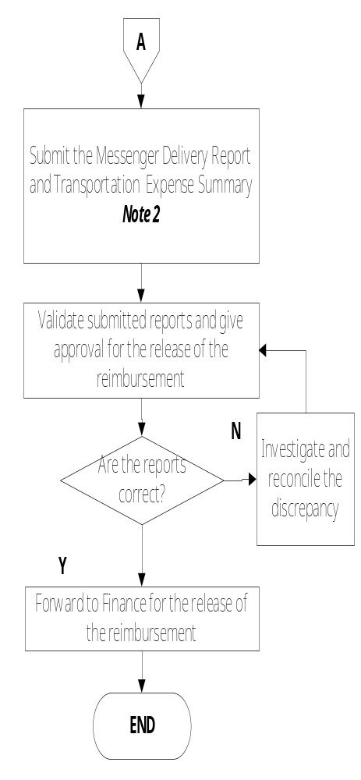 | Administrative Assistant Messenger Delivery Report Transportation Expense Summary  AP Accountant Communications Delivery Staff

V. References
- Messengerial Request Form
- Guidelines for Delivery Service

- Quality Records
- Messenger Logbook
- Messenger Delivery Report
- Transportation Expense Summary

